CS 255 System Design Document Template

UML Diagrams

UML Use Case Diagram
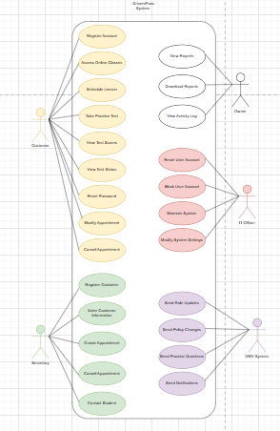

UML Activity Diagrams
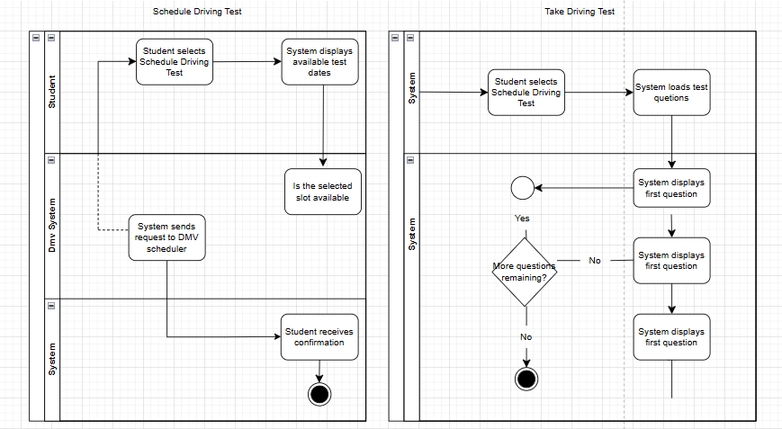

UML Sequence Diagram
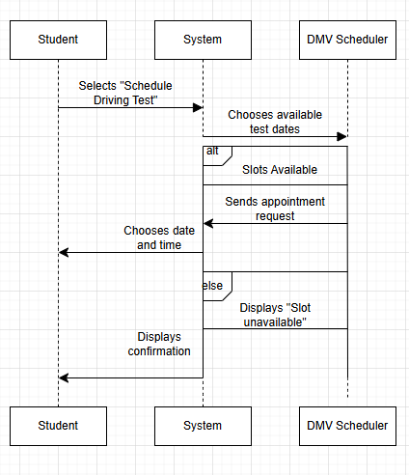

UML Class Diagram

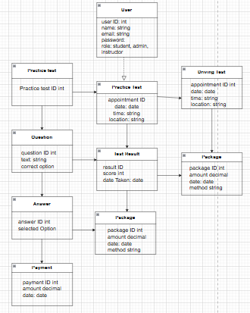

Technical Requirements

Hardware Requirements:
The DriverPass system is designed as a web‑based application, so hardware requirements focus on supporting both client access and backend processing:
• Client Devices:
Students, administrators, and DMV schedulers will access the system using standard computing devices such as desktops, laptops, tablets, or smartphones. No specialized hardware is required beyond an internet‑capable device.
• Server Hardware:
The system requires a reliable server environment capable of hosting the application backend, database, and authentication services. This may be provided through cloud‑based virtual machines or on‑premises servers with sufficient CPU, memory, and storage to support concurrent users.
• Storage:
Persistent storage is required for user accounts, practice test content, test results, driving test appointments, and payment records. Cloud storage or database‑attached storage is appropriate.
Software Requirements:
The system relies on a combination of client‑side and server‑side software to support the functionality represented in the class diagram:
• Operating Systems:
The system must be accessible from common operating systems including Windows, macOS, iOS, and Android.
• Web Browser Support:
A modern standards‑compliant browser (Chrome, Edge, Firefox, or Safari) is required for accessing the user interface.
• Backend Application Framework:
A server‑side framework such as Node.js, Java Spring Boot, or Python Django is required to implement business logic for user authentication, scheduling, test management, and payment processing.
• Frontend Framework:
A responsive web framework such as React, Angular, or Vue.js is recommended to support the student dashboard, practice test interface, and administrative tools.
• Database Management System:
A relational database such as MySQL or PostgreSQL is required to store structured data for the entities shown in the class diagram (User, Student, PracticeTest, DrivingTest, Package, Payment, etc.).
Development Tools:
To support system development, testing, and documentation, the following tools are required:
• Integrated Development Environment (IDE):
Tools such as Visual Studio Code or IntelliJ IDEA for writing and debugging code.
• Version Control:
Git with GitHub or GitLab for source code management and team collaboration.
• Diagramming Tools:
Draw.io or Lucidchart for creating UML diagrams, including the class diagram used in this design.
• Testing Tools:
Automated testing frameworks (e.g., Jest, Mocha, or Selenium) to validate system functionality and ensure reliability.
Infrastructure Requirements:
The system requires a secure and scalable infrastructure to support user access, data storage, and external integrations:
• Web Hosting / Cloud Deployment:
A cloud platform such as AWS, Azure, or Google Cloud is recommended to host the application, database, and API services. This ensures scalability as the number of students grows.
• Authentication and Security:
The system must support secure login for multiple user roles (student, admin, instructor). Passwords must be encrypted, and all communication should occur over HTTPS.
• Payment Processing Integration:
A secure payment gateway (e.g., Stripe or PayPal) is required to support the Payment class and handle transactions for lesson packages.
• Scheduling and Notification Services:
Infrastructure must support driving test scheduling, including communication with DMV schedulers and automated notifications for appointment confirmations or changes.

